**OOZIE AND SQOOP**

**ASSIGNMENT 10.2**

Implementing the concept given in below blog link and share the complete steps along with

screenshots.

[**https://acadgild.com/blog/loading-data-into-hbase-using-pig-scripts/**](https://acadgild.com/blog/loading-data-into-hbase-using-pig-scripts/)

Start all the services for the hdfs terminal.

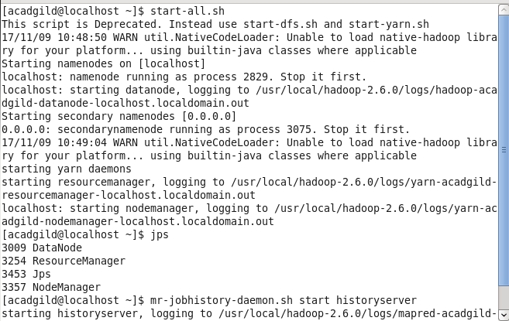

Will see the file and directory present in hdfs mode.

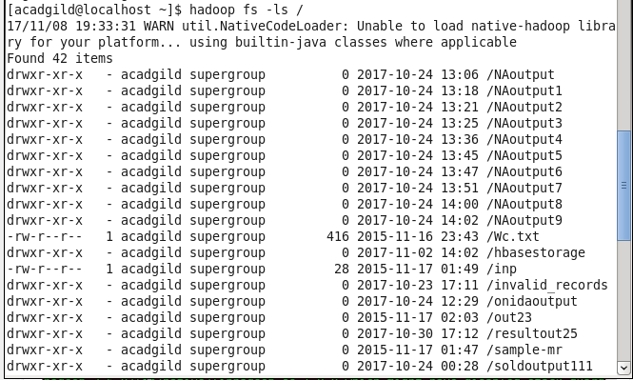

We will be copying the data set in to HDFS which will be further loaded into HBase**.**

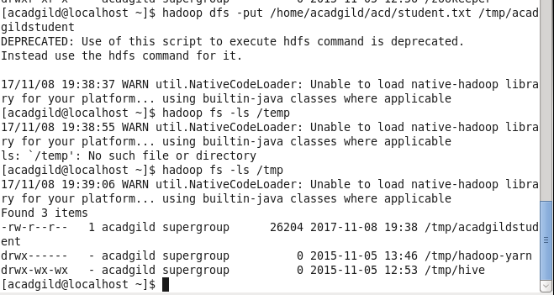

We will be including few jar files of HBase to the Pig classpath.

PIG_CLASSPATH=/home/hadoop/HADOOP/hbase-0.98.4-hadoop2/lib/hbase-server-0.98.4-hadoop2:/home/hadoop/HADOOP/hbase-0.98.4-hadoop2/lib/hbase-*.jar**;**

We will now start HBase shell and create a table

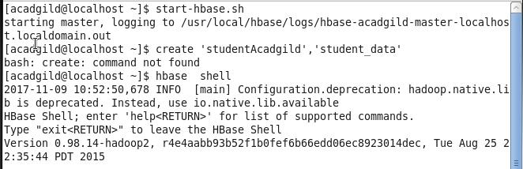

We only need this table as skeleton so PIG can Store data inside this by referring the table name.

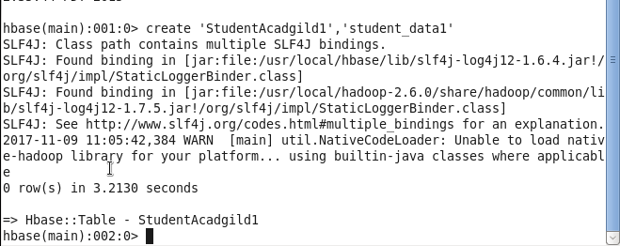

We can come out from HBase by typing exit and switch to PIG grunt shell.

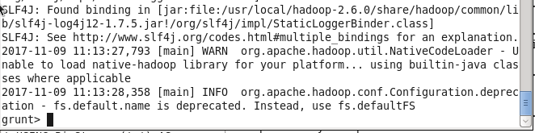

Once we are inside PIG mode we can load data from HDFS to Alias relation.



Now we can transfer the data inside HBase by STORE command.

We need to ensure that we give the correct name for table name created inside HBase. Also the parameters should be kept in mind to avoid mistake.

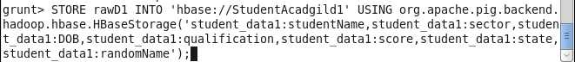

Once the success message comes as shown below , it is confirmed our data is loaded inside HBase.

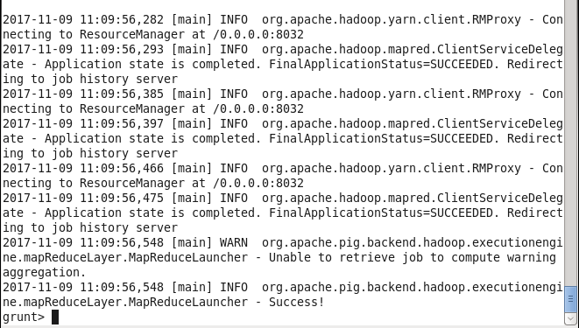

The result can be displayed through scan command followed by table name inside quotes( ‘ ‘ ).



